ITEC 445
- Implement the network of Figure 1. Full connectivity must exist between any two devices.
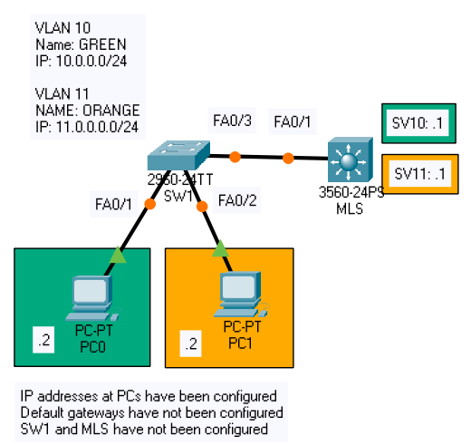
Figure 1. Network for Exercise 1.

Device | Description | Points
End devices | Configure IP address and default gateway | 10
L2/L3 switch | Create and name VLANs | 10
L2 switch | Configure access port/s | 10
L2/L3 switch | Configure trunk/s | 10
L3 switch | Enable IP routing and configure SVIs | 10
Connectivity | Connectivity exists between any two devices | 10
Table 1. Specifications, Exercise 1.

